Raise Money to help homeless people

Ed raised over £1,000 in 1 hr 29 mins
by running a half marathon
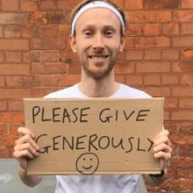

And this Ace team cycled to Brighton,
raised £9,000 and all got medals!

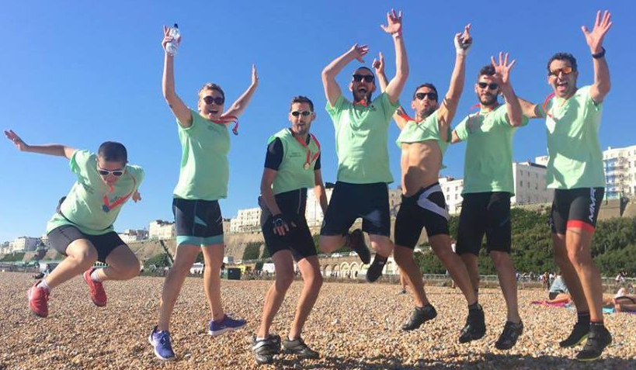

…Running, Cycling, Cake Baking, Head Shave, Plant Sale, Quiz Night…

Whatever you want to do, make it
count for even more.

