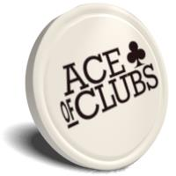

Ace of Clubs, in partnership with Morley College, invite you to
INTRODUCTION TO COMPUTER SKILLS

What will you learn?
You will be introduced to key computer skills and develop these as the course progresses. You will improve your Word skills and find out how to apply for jobs online, research information on the internet and learn about online safety. You will also be able to gain a City and Guilds qualification at the end of the course, depending on your level.

Dates and Times
Advice and Assessment Session
Friday, 20 September, 09.45-11.45 (you must attend this session)
Course Dates
Thursday and Friday, 26 September – 25 October
09.45-11.45

Location
Ace of Clubs, St Alphonsus Road, London, SW4 7AS

To book your place, or for more information
Please speak to Natalia or call 020 7720 2811

